

**Cross Words**

**Monthly Newsletter of Cross Ev. Lutheran Church**

**November 2014 Volume 14, Issue 11**

**The Sons of Thunder**

So much could be said about James and John individually. James was the first apostle to be martyred, dying by Herod’s sword in the early days of the New Testament church. John was the “disciple whom Jesus loved,” probably the only one to die of old age, and the writer of five books of the Bible.

It would, however, be hard to separate these two men who had so much in common. They were both sons of Zebedee and Salome. They were both fishermen. Along with Peter, they were both part of Jesus’ innermost circle. In addition, they apparently both shared a prominent character trait that led Jesus to call them the Sons of Thunder.

A few incidents from Scripture help us understand why our Lord would give them such a fierce nickname. On one occasion, when some Samaritans told Jesus to stay away from their village, James and John asked if they could call down fire from heaven on the Samaritans. Perhaps it was the same zeal for Jesus’ honor that led John to report how he and James had told a man who was not one of the Twelve to stop doing miracles in Jesus’ name. Later we see their ambition focused a bit more inwardly as the two men let their mother request for them the top spots in Jesus’ kingdom. On each of these occasions, our Lord had to correct them. Call it what you will: zeal, enthusiasm, passion; these men were fired up about Jesus and their work! Unfortunately, that desire was at times misguided or misplaced.

How quickly our own eagerness to be faithful to God can cause us to resent those around us who are not so eager! How easily our drive for doing God’s work can become a selfish ambition, a seeking of glory for ourselves instead of our Savior!

Thankfully, the intensity of James and John was eclipsed by that of Jesus. Jesus’ passion was evident as he resolutely set out for Jerusalem, as he sweat bloodlike drops in Gethsemane, as he bit his tongue at his “trials,” and as he clenched his teeth at his crucifixion. He was so eager to save you and me that he was willing to let the Father’s fire rain down on him and his thunder roll over him in our place, for our sins.

It’s hard not to get fired up about serving a Savior like that, so there’s nothing wrong with making a little noise for him! Be filled with zeal for Jesus and his work—and let that passion always be focused on him and guided by his Word.

© 2014 Northwestern Publishing House. All rights reserved.

Scripture is taken from THE HOLY BIBLE, NEW INTERNATIONAL VERSION.®

[](http://www.timeofgrace.org/)

|  |  |  |  |  |
| --- | --- | --- | --- | --- |
| KMSP |  | Channel 9 | Sundays | 6:30 AM |

**NEWS FROM THE CONGREGATION MEETING**

**Membership Matters:** The following actions were ratified by the voters:

* Receive by reaffirmation of Faith – Willard & Phyllis Sipe
* Received by transfer from Cross of Christ/Coon Rapids, MN – Joshua Kiecker
* Transfer granted to Ken & Virgina Wandersee to Mt Olive/Delano.
* Transfer granted to Sarah Hooge to Shepherd of the Valley/Fargo, ND
* Released to join church not of our fellowship – Arlis Block
* Transferred - Ashton Nelsen to Mt Olive /Shakopee

**Revised Congregation Mission Statement** The voters approved a revised mission statement prepared and presented by the Mission Planning Committee (formerly the Long Range Planning Committee). This statement, in a concise and novel way, summarizes our mission and purpose for existing. All other groups and activities within the congregation ought to be carrying this mission out.

**C**ross Ev. Lutheran Church exists to give glory to our God and Savior by

**R**egular worship and faithful use of the Means of Grace with

**O**utreach to the community, nation, and world through our prayers and offerings by

**S**erving our fellow Christians and community, in turn

**S**trengthening our faith and promoting Christian fellowship.

**Harvest of Talents** The annual “Harvest of Talents” sign-up will take place during the month of November. Sign-up sheets will be posted to volunteer to take part in different activities and areas of service within the congregation. This is an opportunity to give to the Lord and His church of your time and your talents.

**CROSS LIGHTS**

Cross LIGHTS will meet on Tuesday, Nov 4 at 7:30 pm. All ladies of the congregation are invited to attend. Cross LIGHTS provides opportunity for fellowship, spiritual growth and service to the Lord and our congregation.

**C:\Users\user\AppData\Local\Microsoft\Windows\Temporary Internet Files\Content.IE5\1H3DHE9F\MC900048036[1].wmf** **BIBLE STUDIES**

**Adult Bible Study**  meets Sunday mornings, 10:15 am to 11:15 am (*during Sunday School – parents can learn from God’s Word at the same time their children are learning!)* We are study the ***book of Judges.*** We always have coffee and snacks. Make plans to come.

**Walnut Bible Study** We meet in the family room at the Walnut Apartments on the west side of town (behind “The Rosewood” diner) on Mondays at 9:30 am. We will be continuing at study of the ***Gospel of Luke***. The nature of this study enables any to jump in and join, even if you haven’t done so before.

**Men’s Breakfast Bible Study** meets on the 3rd Saturday of the month (Nov. 15) , at 9:00 am. As the name implies, we begin with breakfast (a rotating menu) and study God’s Word from 9:30 am to 10:30 am. We will be starting a new study – ***A Lutheran Look at Catholicism.*** All confirmed men in the congregation are invited to attend.

**SENIOR FELLOWSHIP**

Cross Senior will be hosting its annual Senior Thanksgiving dinner on Thursday, Nov 20. We will start at noon with Thanksgiving Feast – Turkey provided – those attending bring the rest.

We will all have a presentation by Pastor Joel Gaertner, Vice President of Ministry for the The Lutheran Home Association and also National Director of Jesus Cares Ministries.

As always, we are inviting senior’s from neighboring WELS/ELS congregations. All seniors of our congregation (55 and up) are invited and urged to attend. A sign-up sheet will be posted.

**C:\Users\church office\AppData\Local\Microsoft\Windows\Temporary Internet Files\Content.IE5\STL63TEV\MC900445196[1].wmf**

**NOVEMBER BIRTHDAYS**

We wish a Happy Birthday for those members of Cross who celebrate this month. If we missed your birthday contact someone in the church office! Thanks.

**News From Lutheran Mobile Clinic (Central Africa Medical Mission)**

October 2014

***“Is anyone of you in trouble? He should pray. Is anyone happy? Let him sing songs of praise.”*** James 5:13 I’m sure we would say we don’t pray or praise nearly as much as we should, but if we fail to take advantage of God’s offer at times, His offer does not expire. He always loves us unconditionally and will be there EVERY time we call on him. I forget that I am a ***fearfully and wonderfully made child of God who should “hold unswervingly to the hope we profess, for he who promised is FAITHFUL***.” (Hebrews 10:23) Even when I forget to ask, God sends me little reminders of who I am to him.

***“Every good and perfect gift is from above, coming down from the FATHER of the heavenly lights, WHO DOES NOT CHANGE like shifting shadows. He CHOSE to gives us birth through the word of truth, that we might be a kind of first-fruits of ALL HE CREATED.”*** James 1:17-18 What if you didn’t know that? And I don’t mean what if you FORGET it on occasion or perhaps even more than occasionally. What if you didn’t KNOW it at all? What if you didn’t know you had a heavenly Father who was NEVER too busy for you and wants nothing but the best for you? Can you imagine what that would feel like? How would you feel if you truly believed God was not the slightest bit involved or interested in your life, and your worth was purely based on your performance and what others thought of you?

Now close your eyes and imagine the Malawian mission field. What does it look like? A group of women and children gathered under the shade of a tree listening to devotion before the start of clinic? A group of Malawian men attending Bible class taught by one of our missionaries at the Lutheran Bible Institute? A choir wearing brightly colored clothing singing beautiful harmonies in the front of the altar of a small brick church building? How about a middle-aged European woman at an Italian restaurant? Did I lose you with the last one?

A year ago the European woman wouldn’t have been on my list either. The first three were and are certainly accurate images. What I didn’t realize was that was only half the story. Over the past nine months, I’ve begun to see a whole other mission field that exists here. This one may look a whole lot less exotic but is no less important.

Did you know that there are over 100 international humanitarian aid organizations operating in Malawi right now? Those organizations employ a significant number of people from Europe, Asia and the US. Many of them are simply people who want to make a career of helping people. Many of them have become friends and acquaintances of mine, and their genuine desire to help others is not unlike yours and mine. However, this past month God has opened my eyes quite a bit wider to Ephesians 2:10. ***“For WE ARE GOD’S WORK- MANSHIP, created in Christ Jesus to do good works, which God has PREPARED in advance FOR US to do”***. Ephesians 2:10

But what if you didn’t know there was a loving God with a plan and purpose for you and your life? This past month, a few worker friends of mine had some really tough days. There problems would be difficult for even the strongest Christian, but as non-Christians they individually expressed to me a sense of fatalistic hopelessness that things would never improve. They truly believed there was no reason for hope. I was a bit caught off guard by their despair because they were the confident, successful, optimistic people I would usually laugh with about the day’s challenges and frustrations. I hadn’t done more than offer the occasional invite to church or shared a bit about what I believed. I realized God was telling me I had to do better job of recognizing my neighborhood was a mission field, too.

A mission field of seemingly ‘Happy’, ‘well-adjusted’ people at home can be easy to overlook when you know there are sick orphans, single mothers or persecuted Christians in the world. Yet, God reminded me rather emphatically this month that when he said, “Go and make disciples of all nations,” he didn’t intend for us to skip over our next door neighbor’s house. While CAMM’S mission field in the villages of Malawi is dearly important to Him, the mission field at Applebee’s the next time you meet your friends for lunch is equally important. That’s great news because, although we may not all be able to go to a rural village in Malawi, we can definitely all go to dinner.

In Christ, Alison Westphal

**News From**

**West Lutheran High School**

[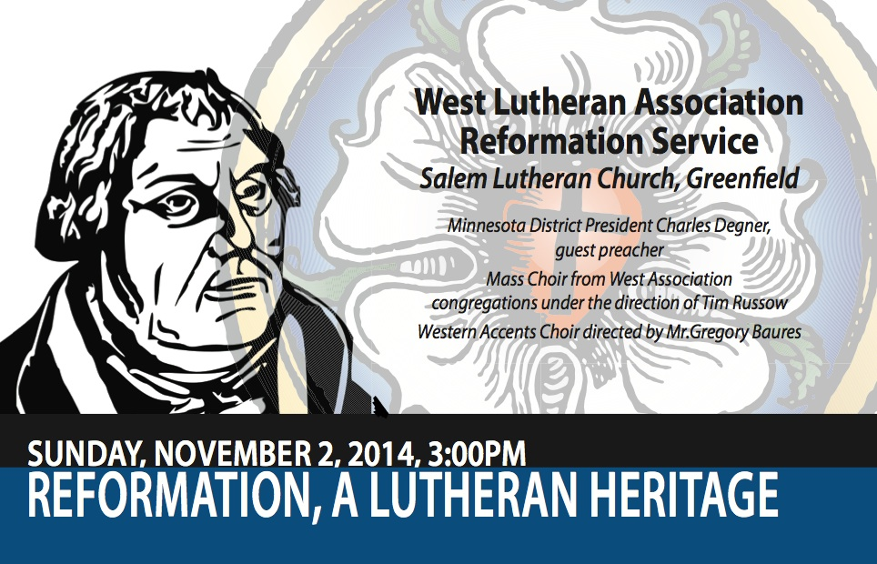](http://wlhs.us2.list-manage2.com/track/click?u=816d0f6a8e429de9f40bf38a3&id=bcec0a1e11&e=b1960f19f7)



|  |
| --- |
| **Fall Children’s Theatre Production** |

## **Veterans Day**

Join us at West Lutheran High School on November 11 as we honor all of the Veterans who have served our country. A light breakfast will be served at 9am, followed by chapel and a Veteran's Day Ceremony at 9:30am.  Thank you to speaker First Sergeant John “Hans” P. Naumann member of the United States Army.  Please RSVP to Lorraine Gerdes via [email](mailto:lgerdes@westlutheran.net?subject=Veterans%20Day) or at 763.509.9378. 

**NEWS FROM THE WELS**

The Conference of Presidents (COP) held its fall meeting Oct. 13-16. In addition to the regular discussions regarding congregations and called workers, the COP took the following actions:

* Adopted a timetable for the special offering to be held in the fall of 2015 intended to eliminate the synod's capital debt.

Adopted a timetable for the special offering to be held in the fall of 2015 intended to eliminate the synod's capital debt.

* Made changes to clarify and strengthen the process that determines whether former called workers will be restored for eligibility to be called into the public ministry.
* Extended for another year the call to Rev. Jon Hein as the director of the Commission for Congregational Counseling (CCC). The COP recognized that good progress is being made and that the CCC is providing significant benefits to congregations as they address challenges and opportunities in their ministry.
* Called Mr. Bradley Price to serve as the director of WELS Prison Ministry.
* Approved a proposal to gather additional statistical information from congregations, specifically in the areas of the overall age of members.
* Reviewed plans presented by the Reformation 500 committee. One significant project will be the development of a documentary of the life and work of Martin Luther.
* Continued work on the revision of the paper, “Marriage, Divorce, and Remarriage.” The revision attempts to clarify the proper application of biblical principles, especially as they relate to pornography and the Internet. The revision is nearing completion and will be available sometime in 2015.
* Decided that, when in-depth study of matters of doctrine and practice become necessary, the COP will assign the study to specially appointed ad hoc committees. The COP prefers this approach to having a standing doctrinal commission that addresses all doctrinal studies.
* Decided to list staff ministers in a separate category in the synod yearbook beginning in 2016. Currently staff ministers are listed with teachers.

The COP also received the following reports:

* Michigan District President John Seifert provided a progress report on the Wartburg Project, a private and independent effort by WELS and Evangelical Lutheran Synod pastors to produce a new translation of the Bible by Lutherans.
* Wisconsin Lutheran Seminary Professor Richard Gurgel provided an update on Grow in Grace, the seminary’s institute for continuing education.
* Representatives of the WELS Military Services Committee outlined the changes that have taken place in the policies and regulations dealing with military chaplains.
* Martin Luther College Professor Jon Schaefer reviewed the progress in the New Teacher Induction program
* Representatives of the WELS VEBA plan shared plans to provide information to congregations regarding the benefits of WELS VEBA to our congregations and workers.

**HYMNAL PROJECT SURVEY**

The WELS Hymnal Project team is asking for your input. Be a part of the development process by filling out a survey about the current WELS Christian Worship and Christian Worship: Supplement hymn books and how WELS members use them in worship and personally. It will take about 20 minutes.

During 2014, the WELS Hymnal Project has conducted three previous surveys to solicit input about how the current hymnal is being used and how the new hymnal can best serve our church body. The first was for pastors, the second for teachers, and the third for musicians. This fourth [survey](http://www.wels.net/worship/hymnal-project-member-survey), intended for all WELS members, will ask for feedback on things like chanting psalms, instruments that accompany worship, wording for the songs and prayers of worship, and singing hymns and songs of the liturgy in four-part harmony.

The survey results will help the WELS Hymnal Project committee analyze the issues that have already been identified and make decisions about the next hymnal. Rev. Jonathan Bauer, communications committee chairman of the WELS Hymnal Project, says, “While the survey isn't by any means a vote, it will help the subcommittees make various decisions. Just as an example, question 22 asks about several items that Christian Worship doesn't currently include that we are considering including in the next book. So we want to know which ones people would find valuable.”

The WELS Hymnal Project is a collaboration between the Conference of Presidents, Northwestern Publishing House, and the Commission on Worship. *The deadline to* [*submit your input*](http://www.wels.net/worship/hymnal-project-member-survey) *is Tues., Nov. 25, 2014. Learn more about the hymnal project at* [*www.welshymnal.com*](http://www.welshymnal.com)*.*

**Serving The Lord In November**

**Date Ushers Greeters Counters**

Sun, Nov 2 Eugene Meyer Brent & Jackie Vergin Jackie & Brent Vergin Dale Sieg

Marty Bogart

Tim Mutterer

Wed, Nov 5 Pete Heibel Lori Peterson Mike & Chris

Jeremy Heibel Kettenacker

Sun, Nov 9 Tom Ernst Gary & Diane Zimmermann Dan & Emma Hanson

Mike Ohm

Phil Ernst

Mark Kettenacker

Wed, Nov 12 Roger Bechtold Merrill & Barb Baker Chuck Landeck

Sun, Nov 16 Chuck Landeck Ken & Sharon Koehler Rudy Wassermann

Rudy Wassermann Lynn Marschel

Bob Randall

Lynn Marschel

Wed, Nov 19 Ken Beise Clint & Elsie Bogart Lori Petersen

Troy Beise

Sun, Nov 23 Brent Vergin Kevin & Jackie Koehler Dan & Emma Hanson Kevin Koehler

Austin Koehler

David Boudreau

Wed, Nov 26 Mike Kettenacker Pete & Avie Heibel Eugene & Arlene Mutterer

Joel Schulze

Thu, Nov 27 Tom Dery Eugene Meyer & Bob Randall Dan Mutterer

## Jimmy Taylor Rudy Wassarmann

John Schuster

### Dan Mutterer

### 

Sun, Nov 30 Tom Ernst Myron & Ann Ohm Marty & Cindy Bogart Mike Ohm

Phil Ernst

Mark Kettenacker